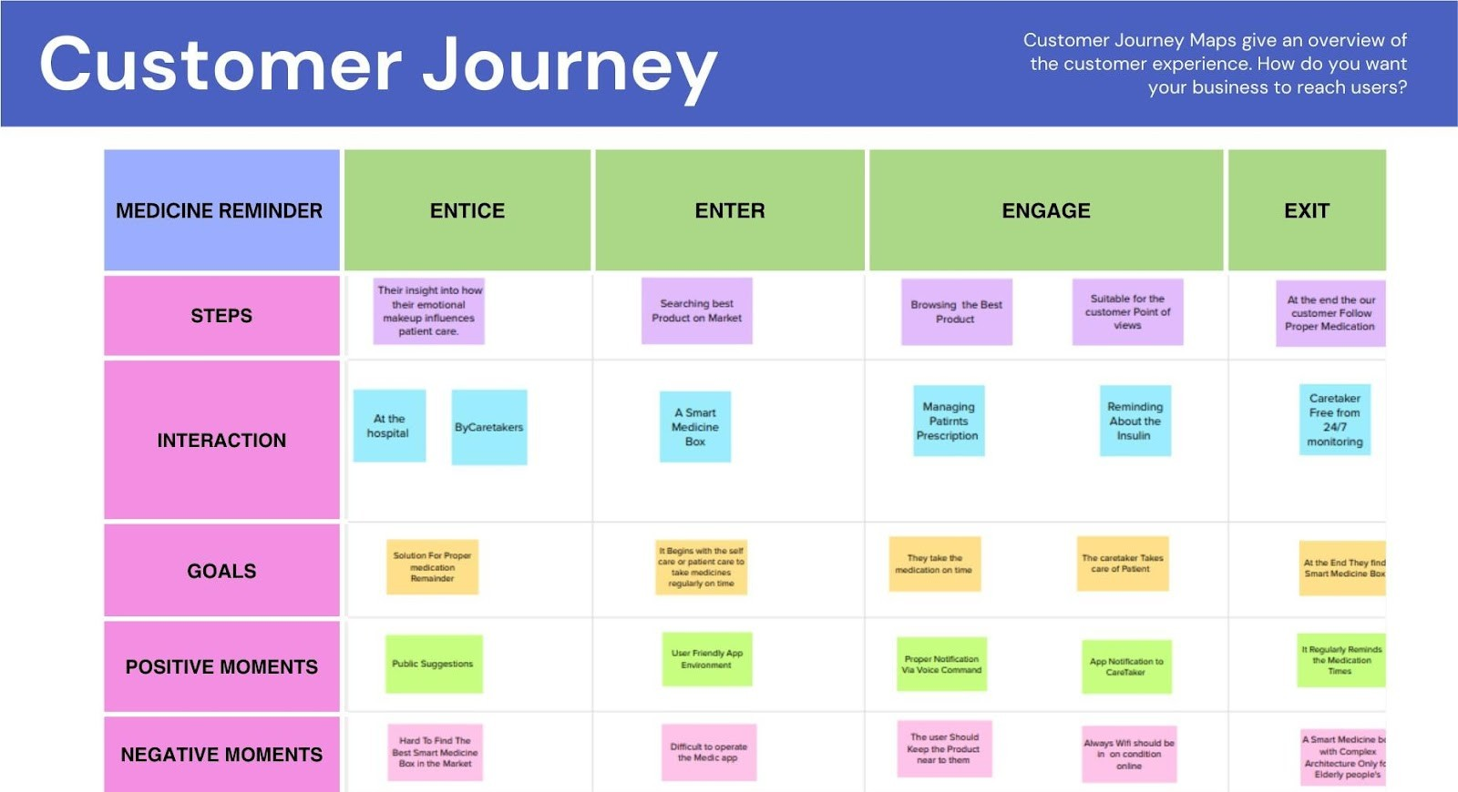

PROJECT DESIGN PHASE - II

CUSTOMER JOURNEY MAP :

|  |  |
| --- | --- |
| Date | 18 October 2022 |
| Team ID | PNT2022TMID43478 |
| Project Name | Personal Assistance for Seniors Who Are Self-Reliant |
| Maximum Marks | 4 Marks |